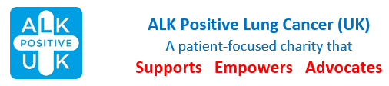
Booking Form
Speedboat Ride, River Thames
Saturday 26th April 2025

Take a thrill ride along the River Thames, passing through Tower Bridge towards Canary Wharf. You will experience a high speed adrenaline ride set to the music of James Bond.
Tickets are £48 per person, which is payable to the charity upon booking.
Guests are then invited to join a subsidised London Regional Lunch (patient + one) in Pizza Express.

Lead Booker:
Email:
Telephone:
Address:
Number of additional guests:

Total number of places booked at £48 pp.
Total due:

Total number attending the lunch

Please return this booking form as an attachment to an email to events@alkpositive.org.uk or post to ALK Positive UK, 1 Ethley Drive, Raglan, Monmouthshire, NP15 2FD.

Please pay the booking fee of £48 per person by bank transfer to ALK Positive Lung Cancer UK (55-70-34 and 87815672) – please add your name and “speedboat” for reference, eg John Jones Speedboat or post a cheque to: ALK Positive UK, 1 Ethley Drive, Raglan, Monmouthshire, NP15 2FD.

Rebecca Welsh
Charity Manager
manager@alkpositive.org.uk

