Zip Wire – Snowdonia – 15/17 May 2025
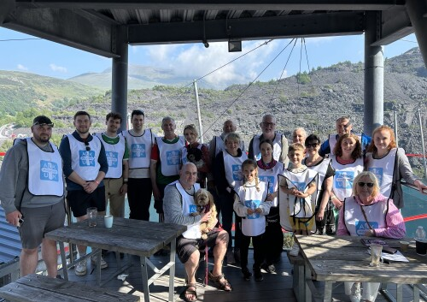
This will be the 3rd year that we have organised this event and, in each of the past two years, we have had a party of about 25 people. Members from all parts of the UK have attended.
The Zip Wire itself will be early afternoon on Saturday 16th but many participants make a weekend of it. You are welcome to bring friends and relatives and, if we are oversubscribed, we will give priority to those who are fundraising. Children can take part providing they are over 1.2 metres in height.
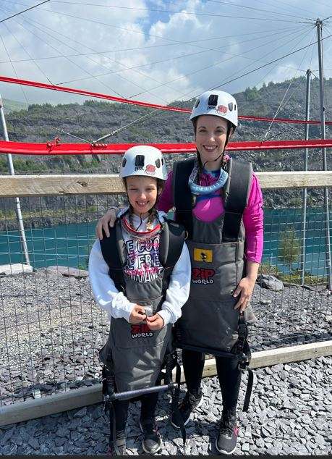
Dependent on availability, we might also be able to accommodate people who just want a pleasant weekend in Snowdonia supporting fundraisers for the charity.
We have booked rooms at the Glan Aber Hotel in Betws-y-Coed, a charming tourist hotspot about 20 minutes drive from the Zip Wire. We have a 10% discount on their normal price.
Some participants will arrive on the Friday in time for dinner at the hotel. Some will leave after the Zip Wire on Saturday but others will stay for dinner on the Saturday evening and leave after breakfast on Sunday morning.
Some will arrive on the Saturday and leave on Sunday morning and some will just come for the Saturday. So, total flexibility. Deb will be there for the full weekend.
In previous years, some have extended their stay and made a long weekend of it. Some will include a train ride to the top of Snowdonia and a few might even walk it.
Sarah & Isabelle
Betws-y-Coed has a railway station, for those not driving. There will be plenty of people to take you to the Zip Wire.
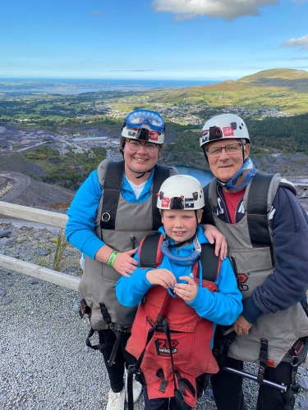
We hope that as many people as possible will use the event for fundraising and we will pay their entry fee to the Zip Wire. Those who are not fundraising will pay the £48 discounted cost of the Zip Wire.
All participants will pay the cost of their accommodation and travel. The cost of the rooms plus a good Welsh breakfast is about £65 per person per night sharing and about £70 per person per night for singles. Family rooms are available. The Charity will book the accommodation, pay upfront and invoice participants.
This is a great way to raise funds for the charity whilst having a very pleasant time with some very nice people.
If you would like to book, please click on BOOKING to complete a short questionnaire.
Please EMAIL me if you require any further information.
Rebecca (Becs)
Stacy & Henry
Manager

